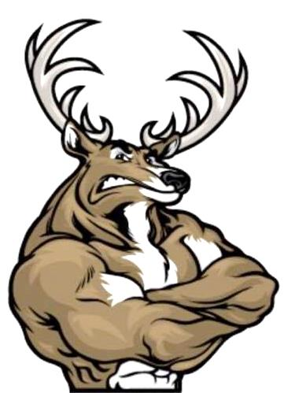
Yankton Youth Wrestling Club
Annual Tournament
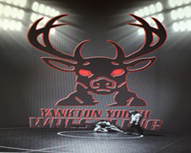
Pic 10 tournament: Trophies for top 3 teams
Sunday, January 6, 2019 Yankton High School 1801 Summit St.
TOTS: 2012 & Later NOVICE: 2007-2006 BANTAM: 2011 – 2010 SCHOOLBOY: 2005-2004 MIDGET: 2009-2008 *Girls will wrestle in boys brackets*
Check in: 10 A.M. – NOON Wrestling 12:30 p.m.
(3) 1½ Minute Periods – South Dakota High School Rules
4 Person Round Robin (when possible)
Mail-in Entries & $10 Registration Fee Must Be Received by January 4th^{d}
$5 Coaching Fee: Must have Coaching Band To Be On Mat/Free with AAU Card
Awards: 1st Place Through 3rd Place Concessions Will Be Served By YYWC – No Coolers Allowed VendorBlender
**Limited To The First 350 Registered / Absolutely NO Entries At The Door**
MAIL ENTRIES TO: INFORMATION: Yankton Youth Wrestling Club Coach Marshall Bahm 610 Maple Street 605-660-7843 Yankton, SD 57078 or email to: yanktonyouthwrestlingclub@gmail.com
_ _ _ _ _ _ _ _ _ _ _ _ _ _ _ _ _ _ _ _ _ _ _ _ _ _ _ _ _ _ _ _ _ _ _ _ _ _ _ _ _ _ _ _ _ _ _
Wrestler Name:____________________________________________Age:____________
Address:____________________________________________________________________
Phone:_________________________Sex:______________Weight:__________________
DOB:_______________________________Years Experience:_____________________
Parent Name:___________________Parent Signature:________________________

